1. Install VisualGDB

2. Create a new project as below:

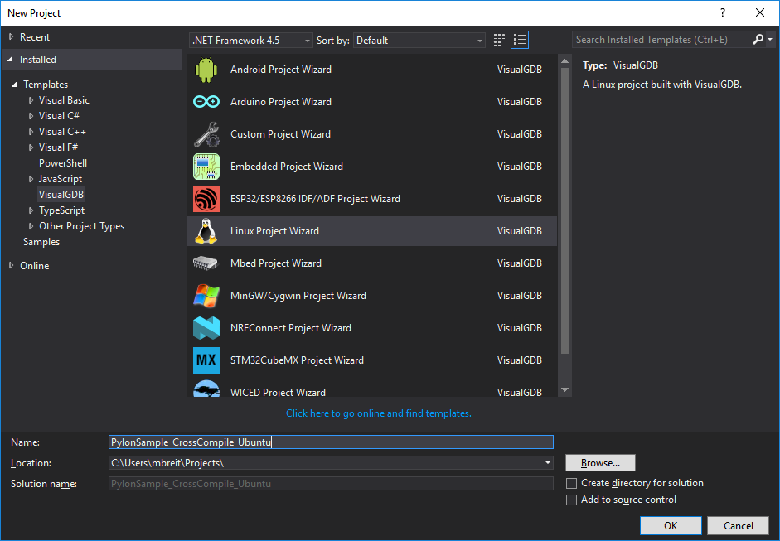

3. If you see this screen, just click ok:

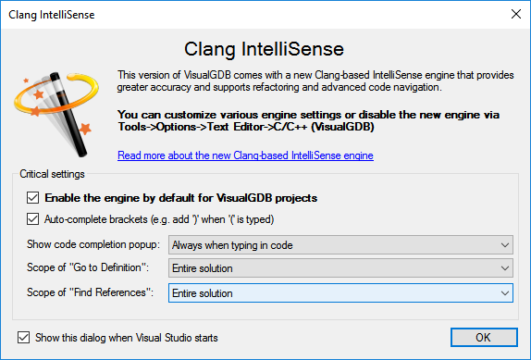

4. Choose the options like below:

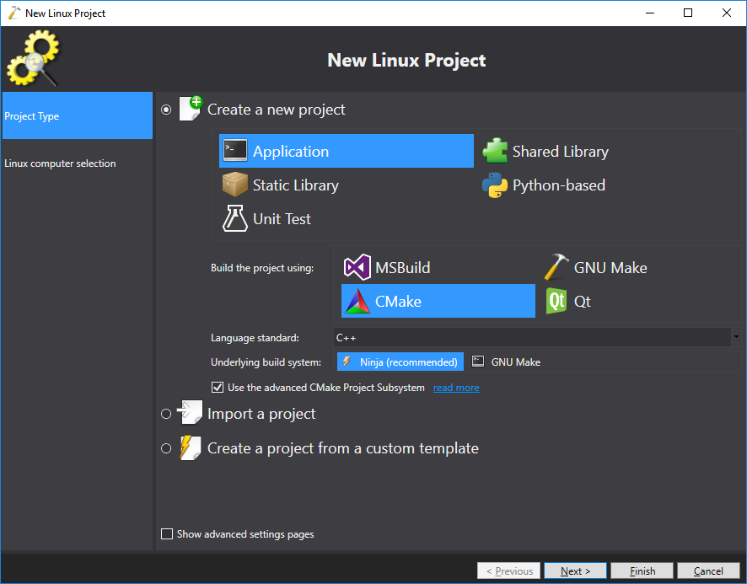

5. Select and install the desired tool chain (in this case Ubuntu). Also choose your deployment target machine:

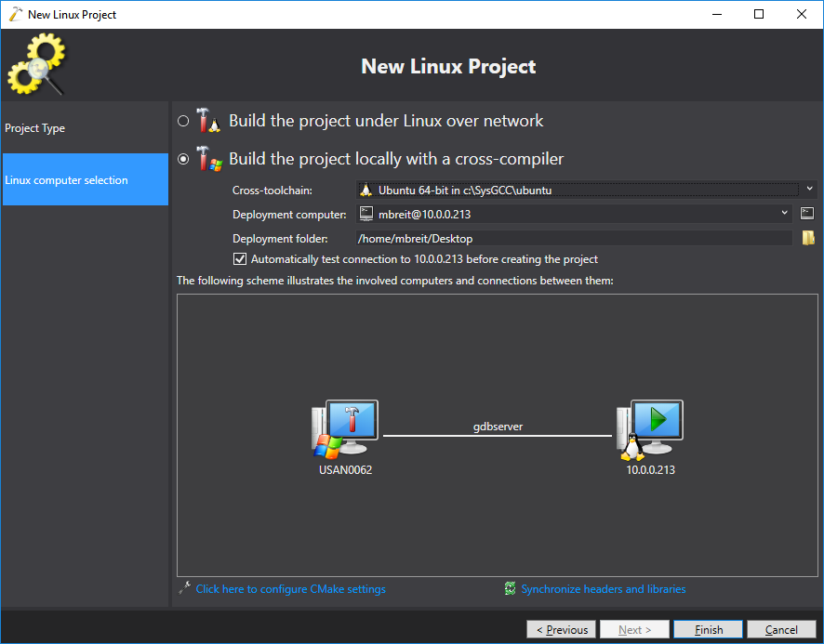

6. This notice was seen when using VisualGDB’s ubuntu tool chain with Ubunutu 16.04. It was ok to ignore it and continue.

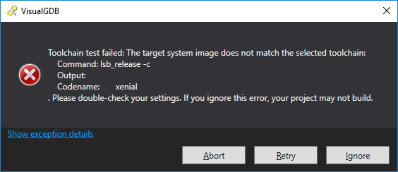

7. If prompted to install gdbserver on the target, do so:

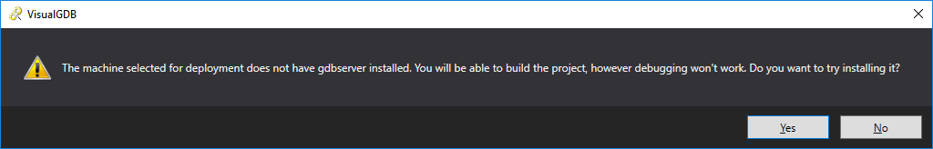

8. Extract the pylon linux SDK into the toolchain sysroot folder on the development PC:

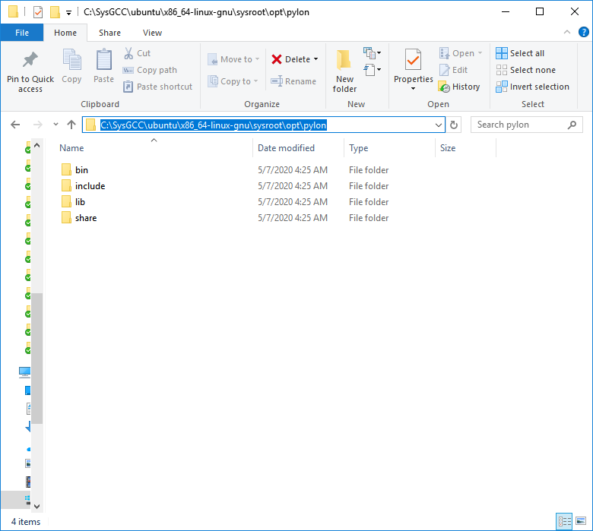

9. It’s best to make sure that pylon is installed into the same directory on the development pc as the target (ie: /opt/pylon on both)

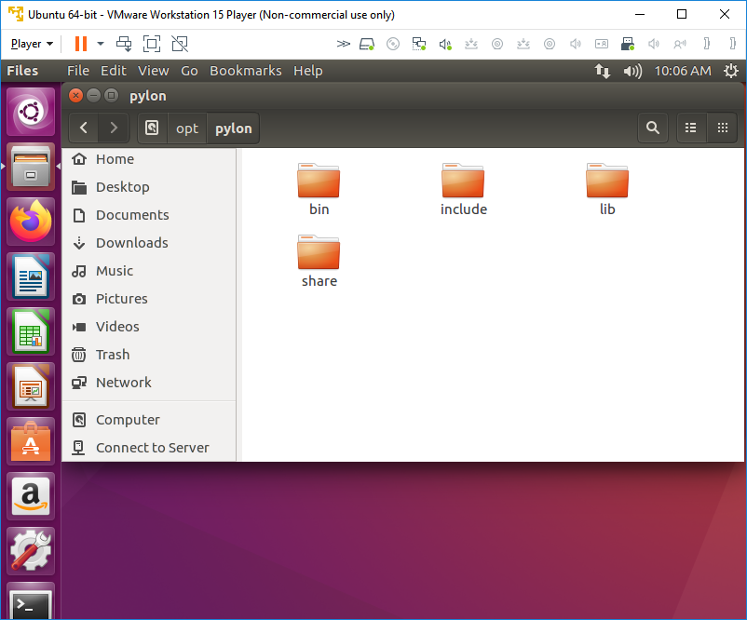

10.

